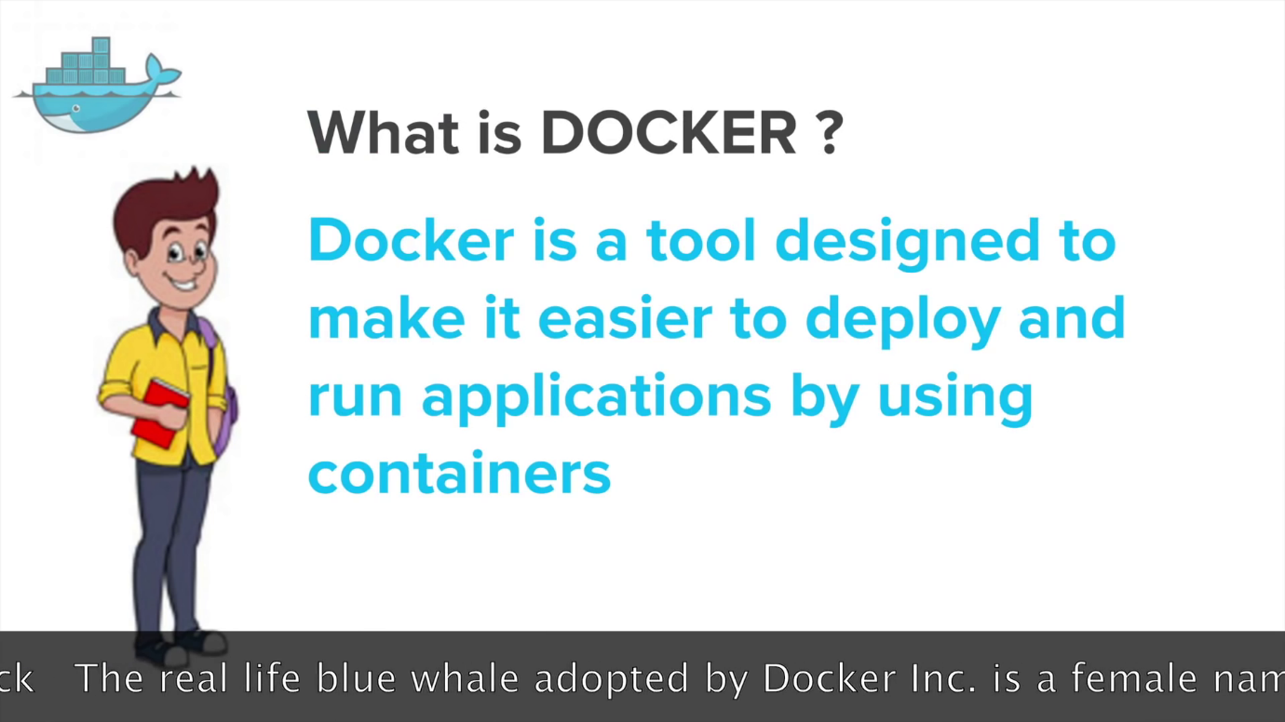

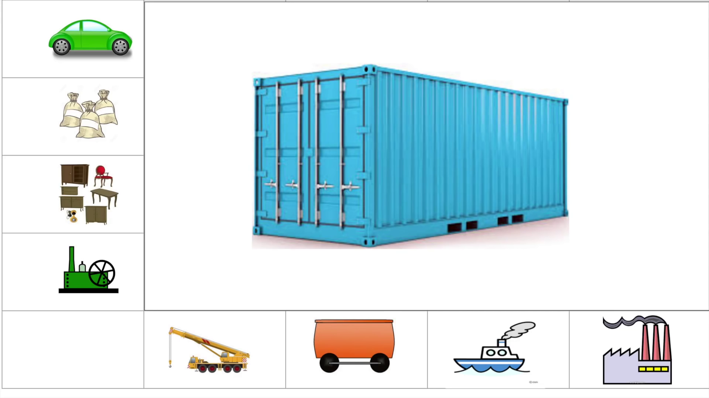

VM vs Container

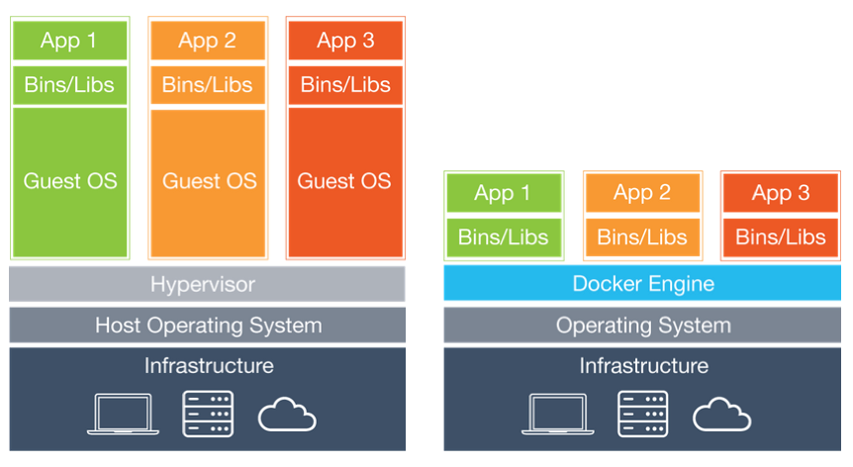

# [**etc/ bin/ and lib/**](https://stackoverflow.com/questions/16643142/what-do-these-directory-is-used-for-in-linux-etc-bin-and-lib)

* etc -> To keep configuration files
* lib -> To keep libraries that can be used by installed software or other softwares in your system.
* bin -> Binary files

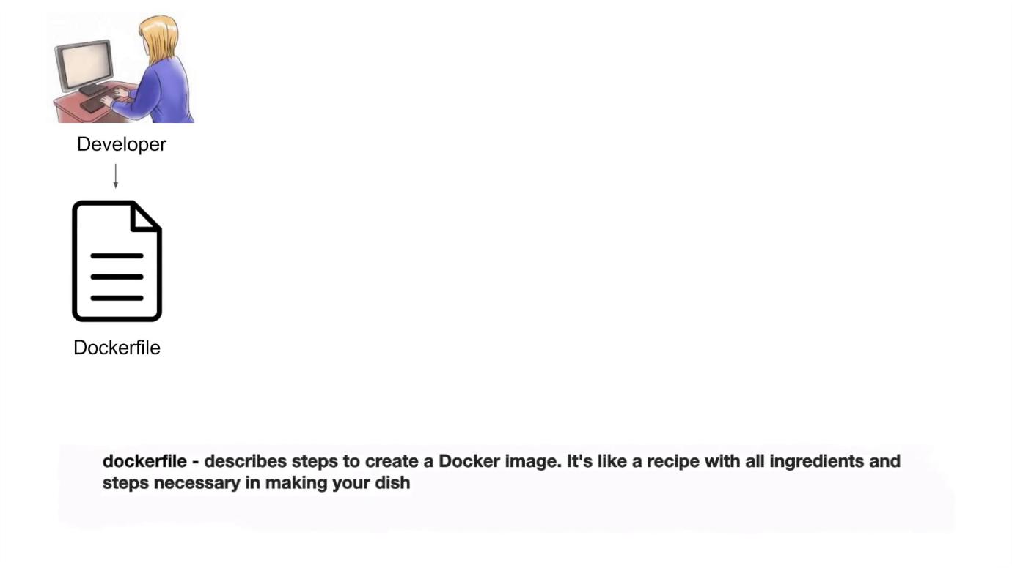

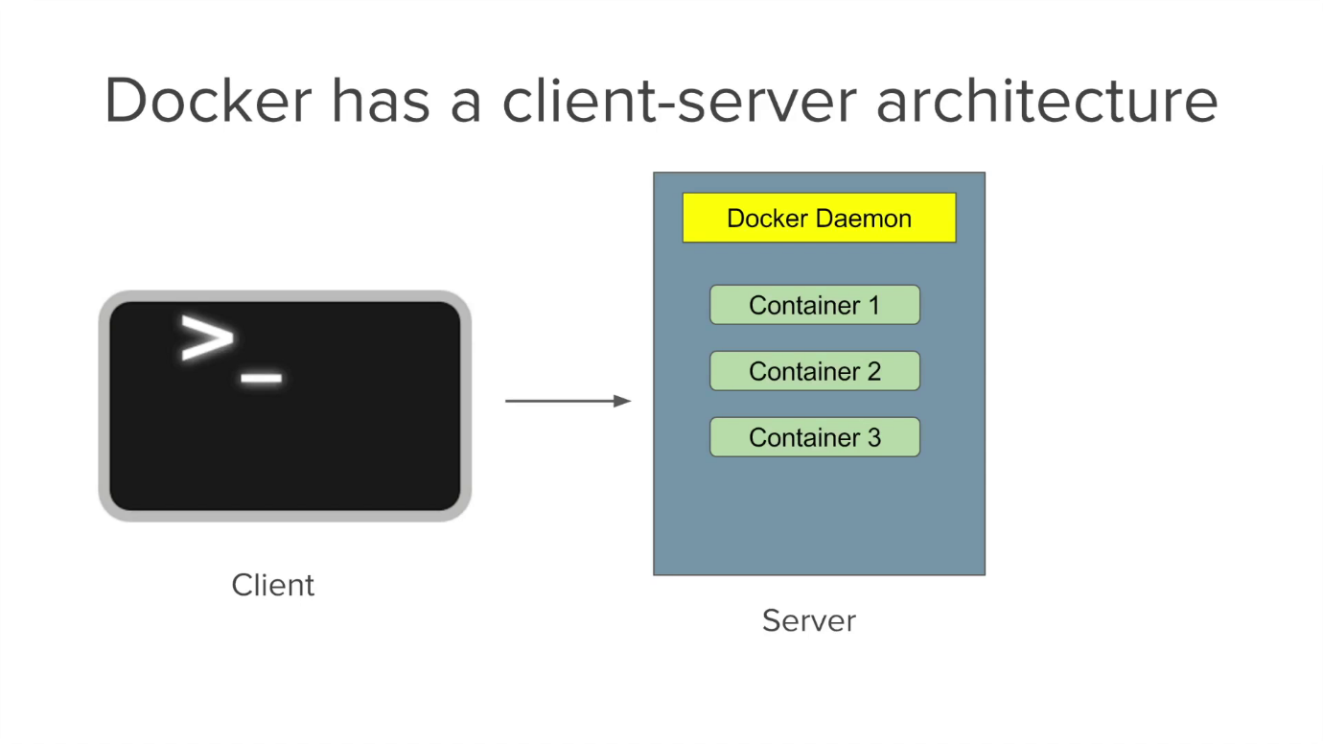

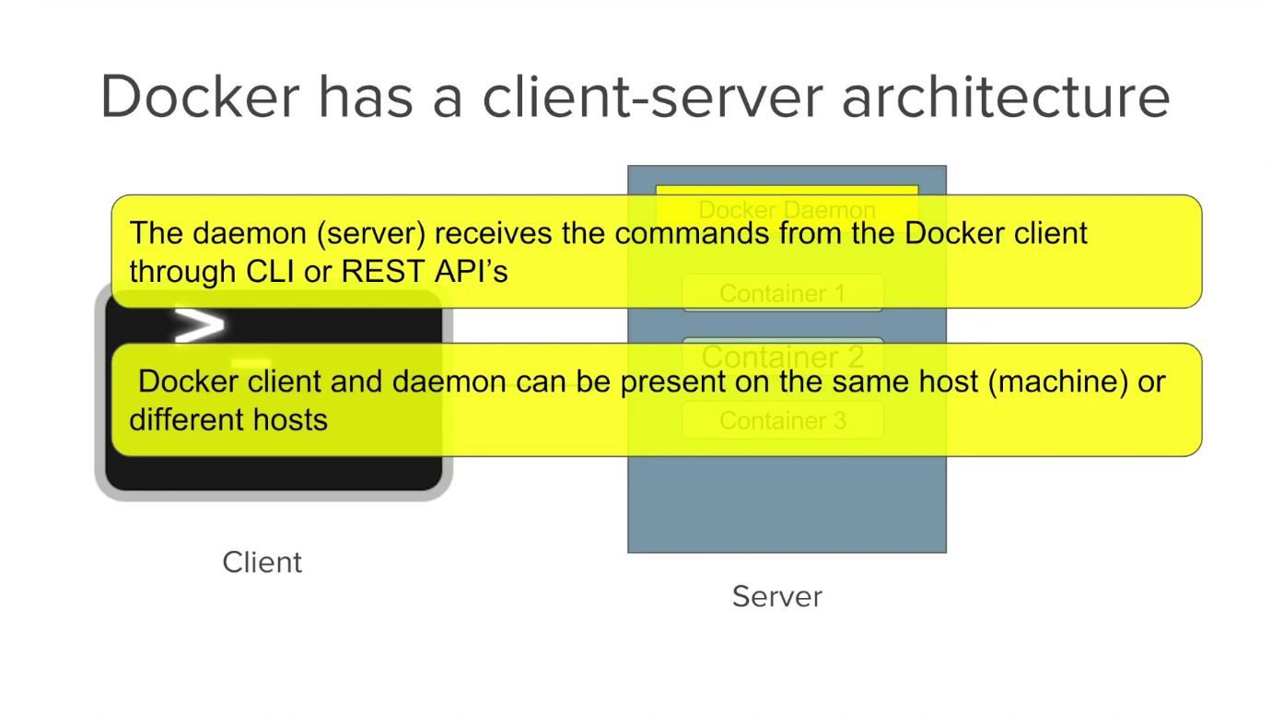

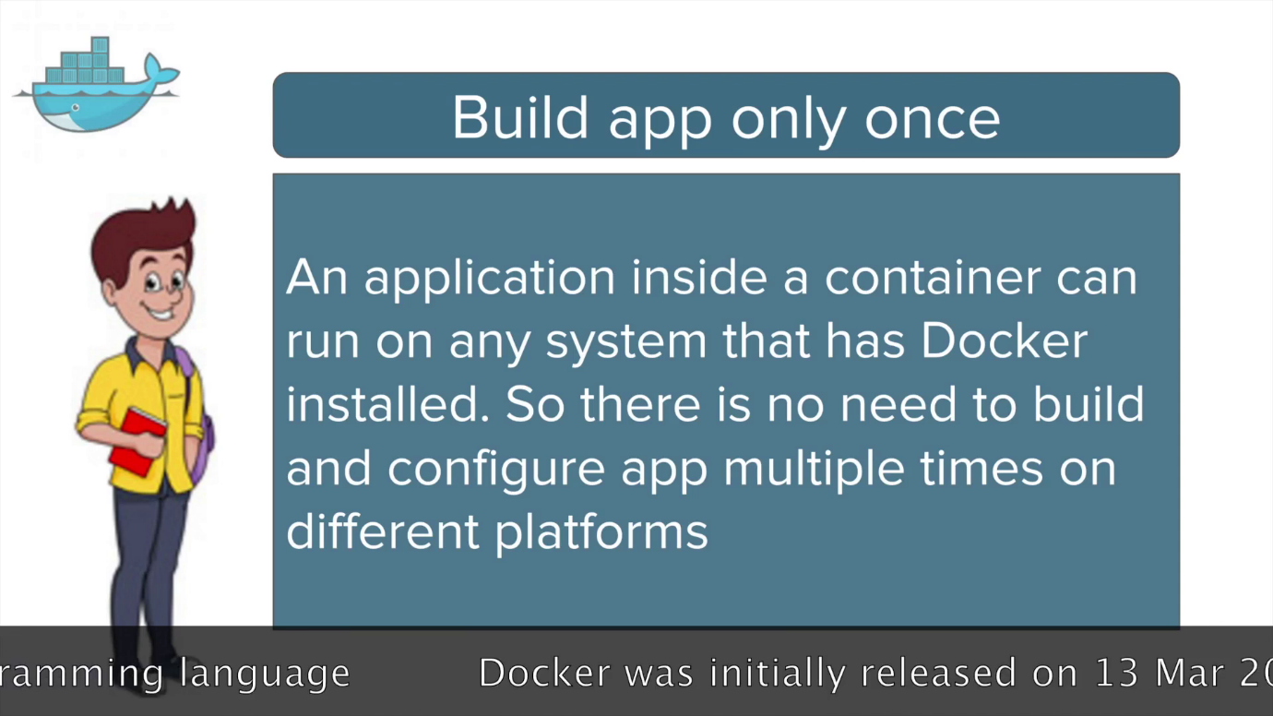

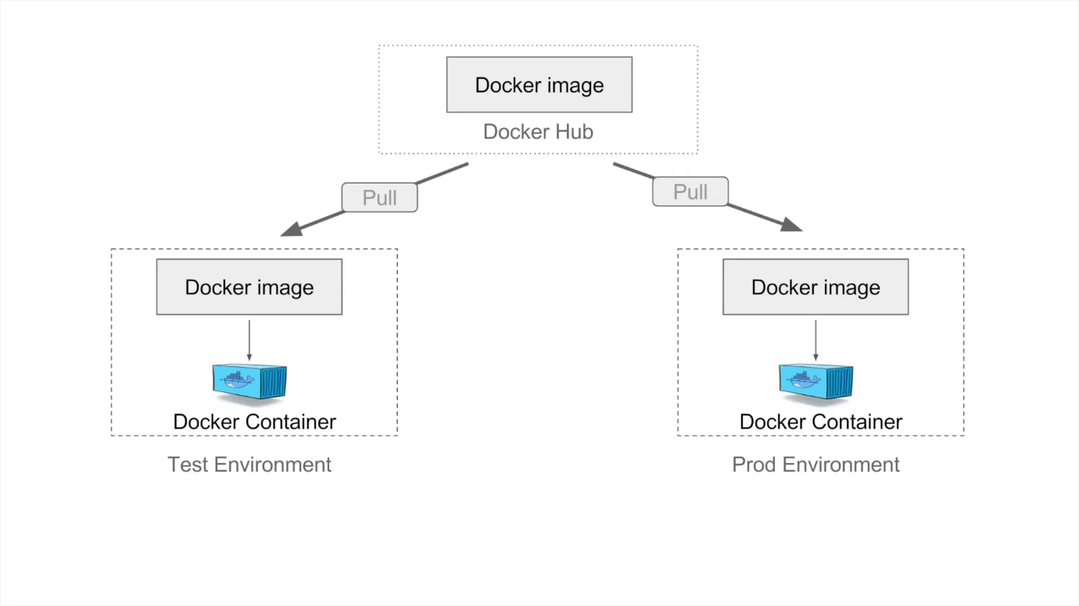

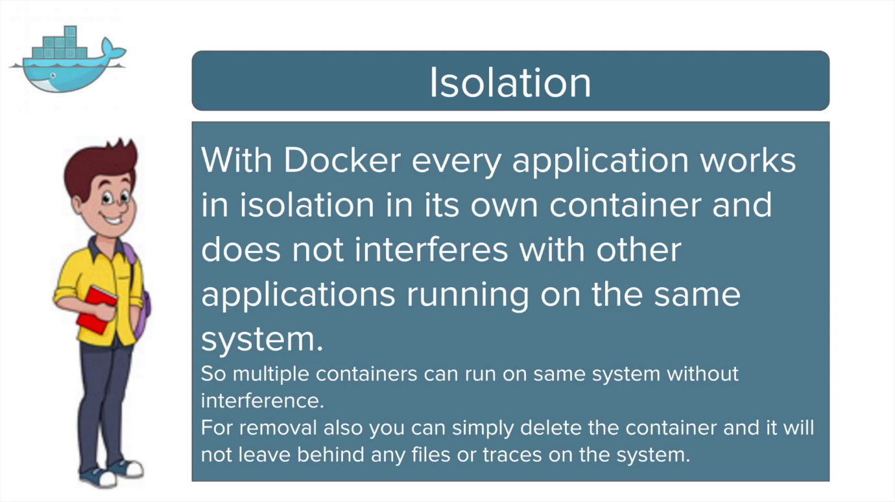

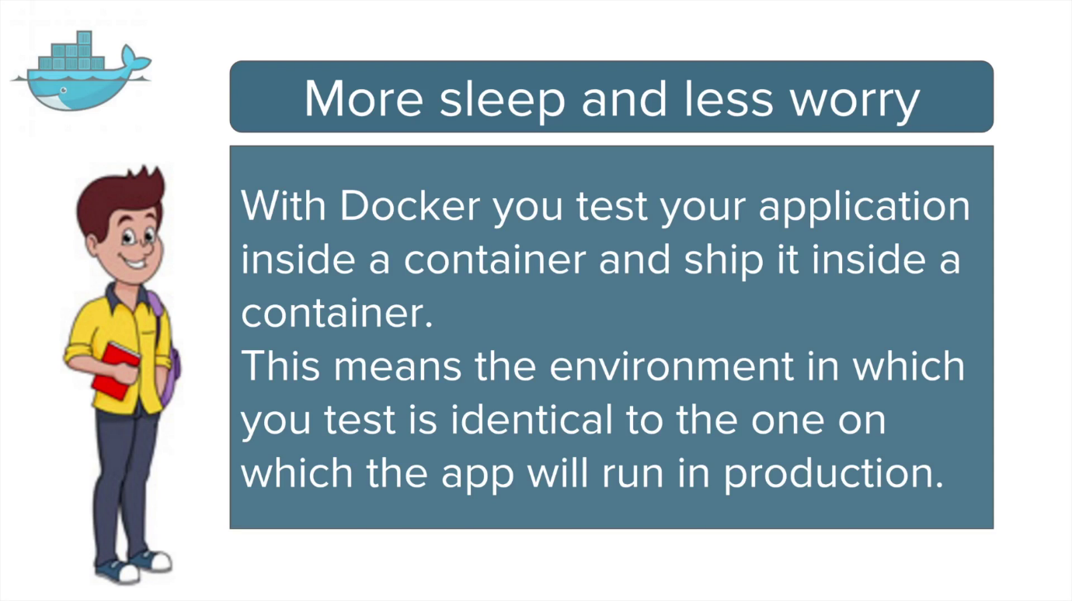

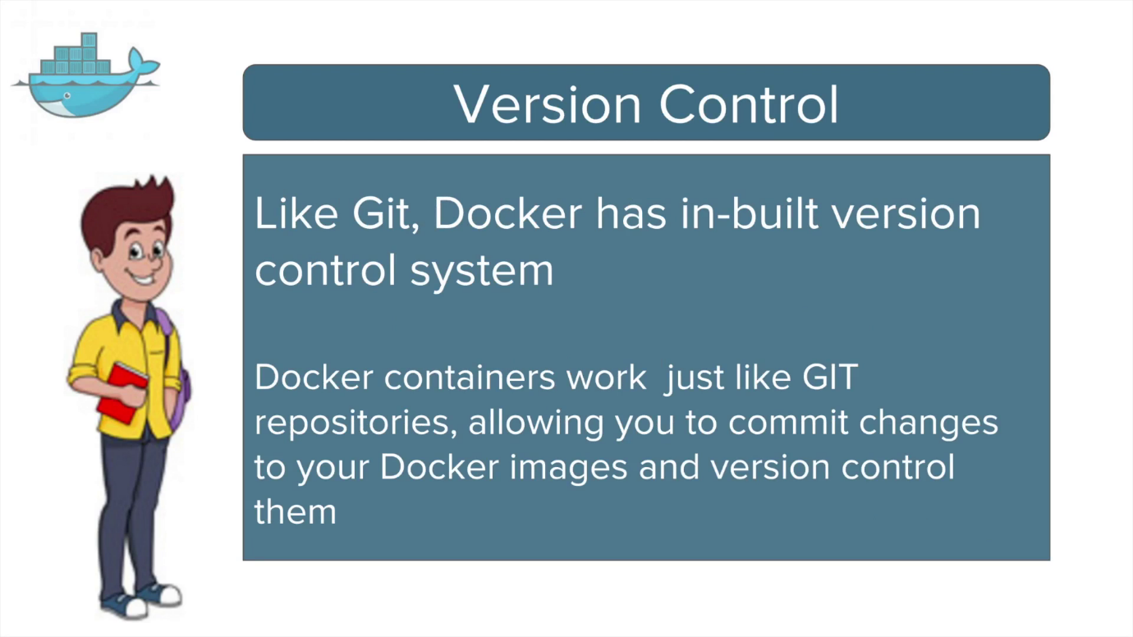

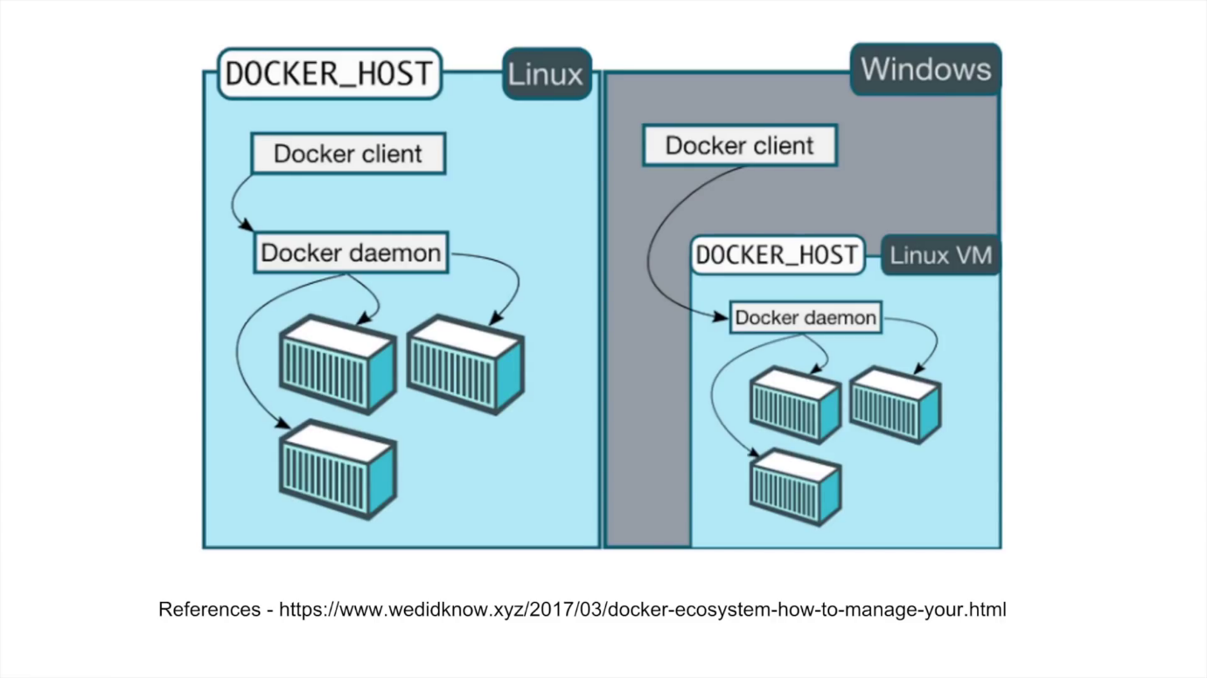

**Docker commands:**

**Docker build :** Build an image from a Dockerfile

**Ex: docker build -t aaa-docker .**

**docker build -t aaa-docker -f /lakshman/Dockerfile**

**Docker tag:**

**docker tag SOURCE_IMAGE[:TAG] TARGET_IMAGE[:TAG]**

**Ex: docker tag aaa-dockerimg aaa-repo-can:data**

**Docker pull to download images from registry**

**Ex: docker pull aaa-core-docker-candidates.repo.lab.pl.alcatel-lucent.com/aaa-dockerimg:19A.20190516061205**

**Docker images – to list of all the docker images**

**Docker ps – to list running containers**

**Docker ps or docker container ls – to list of all running containers**

**Docker run image-name : to star the container**

**Docker stop continer-id : to stop the container**

**Docker rmi docker-image/img-id : to delete the docker images**

**docker run -itd image-name/ID : to run docker image**

**docker exec -it img-id bash : to login into the docker container**